Chapter 4, Problem 97.

A common-emitter amplifier circuit is shown in Fig. 4.152. Obtain the Thevenin equivalent to the left of points B and E.

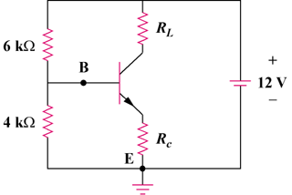

Figure 4.152
For Prob. 4.97.

